Final Project Report

IE 598 Structured Credit

Group: Chengjia Dong, Junru Wang, Yifan Meng

Instructor: Ishan Prasad

Date:October/20/2024

Part 1: Prepayment Modeling

Summary of Prepayment Rates (SMM) Based on Various Factors in 2015 and 2019
This report compares prepayment trends (Single Monthly Mortality or SMM) across key factors such as FICO score, loan balance (UPB), occupancy status, loan purpose, debt-to-income ratio (DTI), and property state in 2015 and 2019. The goal is to highlight key differences and similarities in borrower behavior in response to refinancing incentives.

Key Findings
- Higher Prepayment Rates in 2019: Across all factors, prepayment rates were generally higher in 2019 compared to 2015. Borrowers, particularly those with high FICO scores and low DTI, exhibited greater sensitivity to refinancing incentives.
- Key Similarities:
  - Rising Prepayment with Increased Incentives: In both 2015 and 2019, prepayment rates rose as refinancing incentives increased. Borrowers in both years became more likely to prepay when incentives exceeded 50 bps.
  - High Sensitivity Among Certain Segments:
    - Borrowers with FICO scores above 760 and investment properties showed the highest prepayment rates.
    - Refinance loans had consistently higher prepayment rates compared to purchase or cash-out loans.
- Key Differences:
  - Segment-Specific Trends:
    - In 2019, even high-DTI borrowers were more likely to prepay, narrowing the gap with low-DTI borrowers.
    - Purchase loans in 2019 saw a significant increase in prepayment rates, nearly reaching the levels of refinance loans at high incentive ranges.
- Regional Differences: Borrowers in states like Florida (FL) and Texas (TX) showed a more pronounced prepayment behavior in 2019 compared to 2015, while New York (NY) consistently had the lowest prepayment rates.

Comparative Analysis of Prepayment Rates Based on Key Factors

1. FICO Scores and Refinancing Incentives
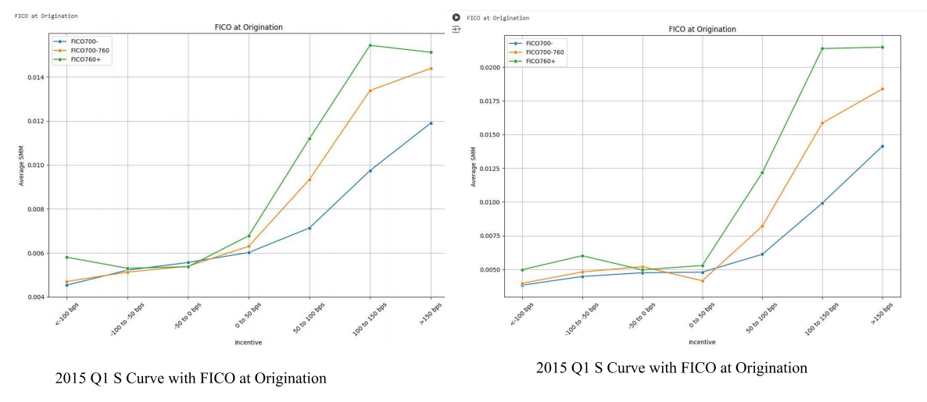
- 2015 vs. 2019: Borrowers with higher FICO scores (760+) showed a sharper increase in prepayment rates in both years, but rates were significantly higher in 2019, especially when incentives exceeded 150 bps.
- Key Difference: In 2019, the gap between high- and low-FICO borrowers widened, reflecting a more pronounced response to refinancing opportunities.

2. Loan Balance (UPB) and Refinancing Incentives
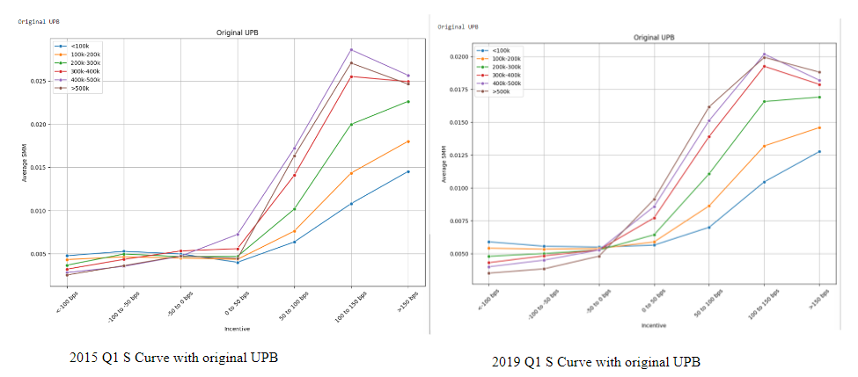
- Larger Loans, Higher Prepayment: Borrowers with larger loans ($500k+) demonstrated greater sensitivity to refinancing incentives. In 2019, prepayment rates for large loans were higher than in 2015, especially in the 150+ bps range.
- Key Trend: In 2019, many high-loan borrowers refinanced early, leading to a decline in SMM after high incentives, a trend less noticeable in 2015.

3. Occupancy Status and Prepayment Rates
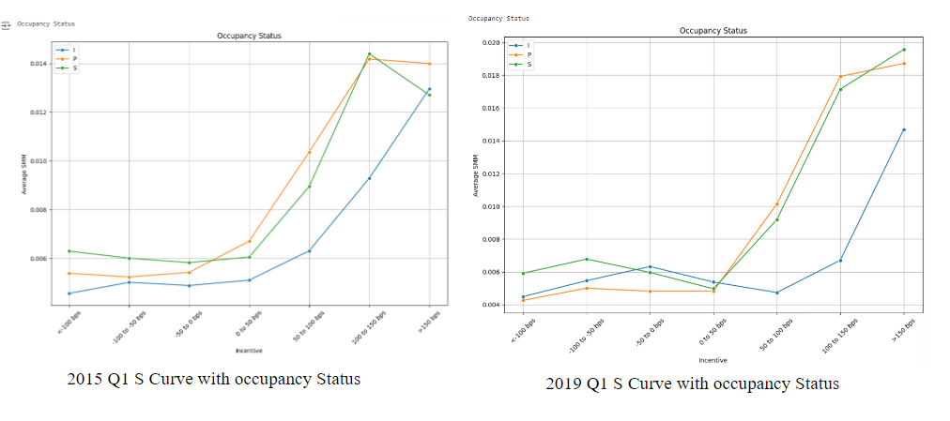
- Investment Properties vs. Owner-Occupied: In both years, investment properties had the highest prepayment rates, while owner-occupied homes had the lowest. In 2019, owner-occupied borrowers showed a stronger response to higher incentives compared to 2015.

4. Loan Purpose and Refinancing Sensitivity
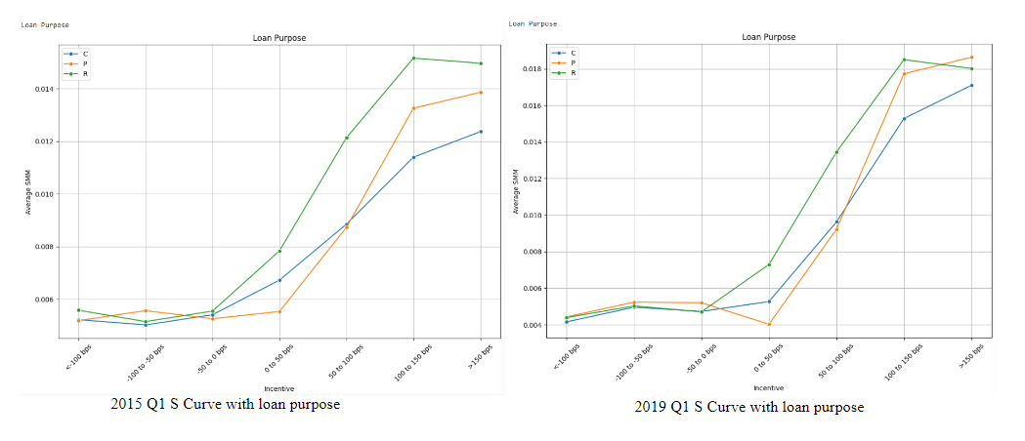
- Refinance Loans Dominate: Refinancing loans had the highest prepayment rates in both years. However, in 2019, purchase loans showed a notable increase in prepayment activity, narrowing the gap with refinance loans at higher incentives.

5. Debt-to-Income Ratio (DTI)
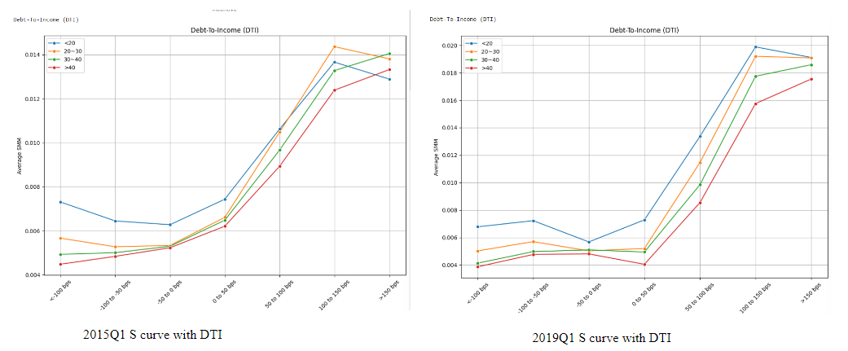
- Low DTI, High Prepayment: Borrowers with low DTI ratios (<20) prepay more frequently, and prepayment rates were higher in 2019 across all DTI ranges.
- Notable Improvement: High-DTI borrowers (40+) showed improved prepayment behavior in 2019, reflecting increased refinancing opportunities.

Analysis of Adjusted Contract Prepayment Rate (CPR) from Jan 2015 to Dec 2019
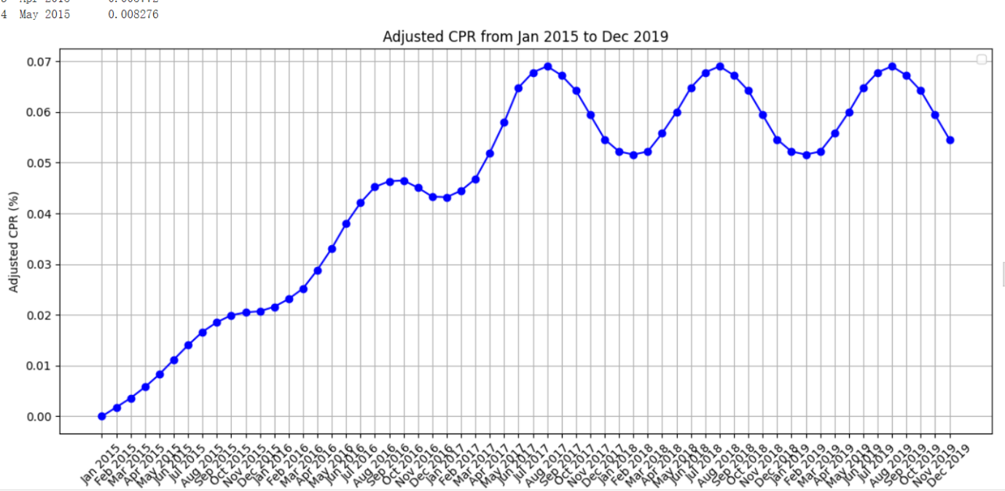
The graph shows the upward trend in Adjusted Contract Prepayment Rate (CPR) from 2015 to 2019. Key insights include:
- Overall Trend: CPR steadily increased from near 0% in early 2015 to around 0.06% by the end of 2019, indicating that more borrowers chose to prepay over time, likely due to favorable market conditions and refinancing opportunities.
- Seasonal Fluctuations: The CPR displays a clear seasonal pattern, with peaks in the summer months (June to August) and troughs in the winter (December to February), reflecting higher refinancing activity in the warmer months.
- Peaks and Valleys: Peaks in 2017-2019 suggest periods of favorable economic conditions or lower interest rates driving more prepayments, while winter months consistently show lower activity.
- Market Impact: The rise in CPR throughout the period is likely driven by lower interest rates and improved refinancing options, enabling borrowers to take advantage of better loan terms.

Lock-in effect
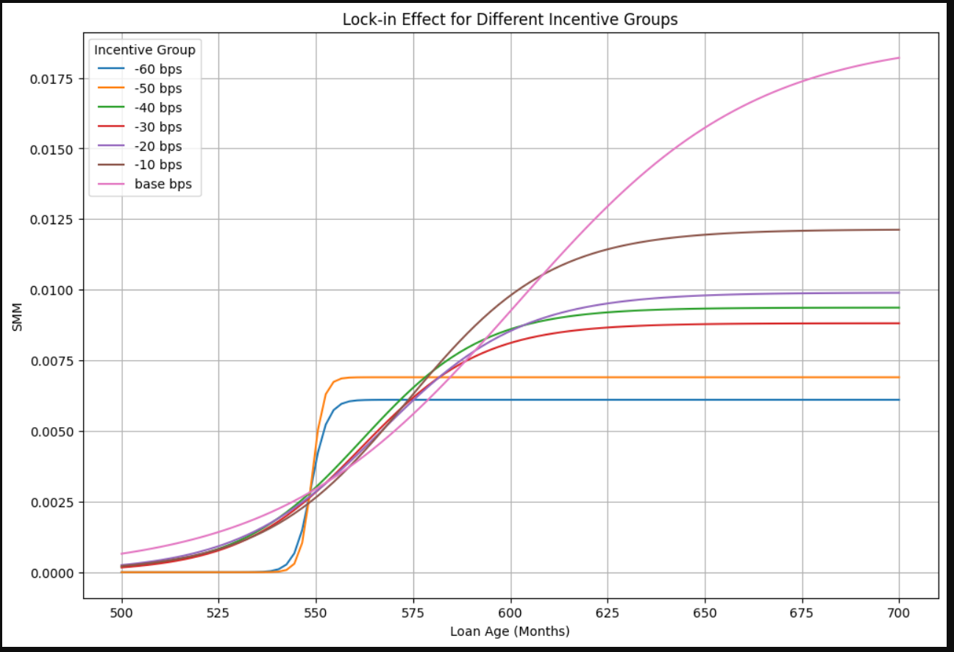
This graph illustrates the lock-in effect across different incentive groups and shows how prepayment rates (SMM) change with loan age (in months) under varying interest rate incentives.
- Interest Rate Incentives:
  - The lines represent different interest rate incentives ranging from -60 bps to -10 bps (negative incentives), meaning current market rates are lower than the original loan rates, providing more incentive to refinance.
  - The base curve represents no incentive, showing minimal prepayment.
- Prepayment Rates Increase with Loan Age:
  - For higher incentives (e.g., -10 bps, purple line), the prepayment rate rises quickly around 550 months, indicating stronger borrower motivation to refinance.
  - Lower incentives (e.g., -50 to -60 bps, blue and orange lines) show slower prepayment increases, with rates stabilizing around 600 months.
- Lock-in Effect:
  - Higher incentives result in earlier and faster prepayments, while lower incentives demonstrate a stronger lock-in effect, where borrowers are less motivated to prepay and prefer to stay with their current loan.
- Plateau:
  - All curves flatten around 600 months, indicating that beyond this point, additional loan age has little impact on prepayment behavior.
The stronger incentives drive quicker prepayment behavior, while lower incentives create a greater lock-in effect, with borrowers staying longer in their original loans.

Curtailment

Analysis of the Graph:
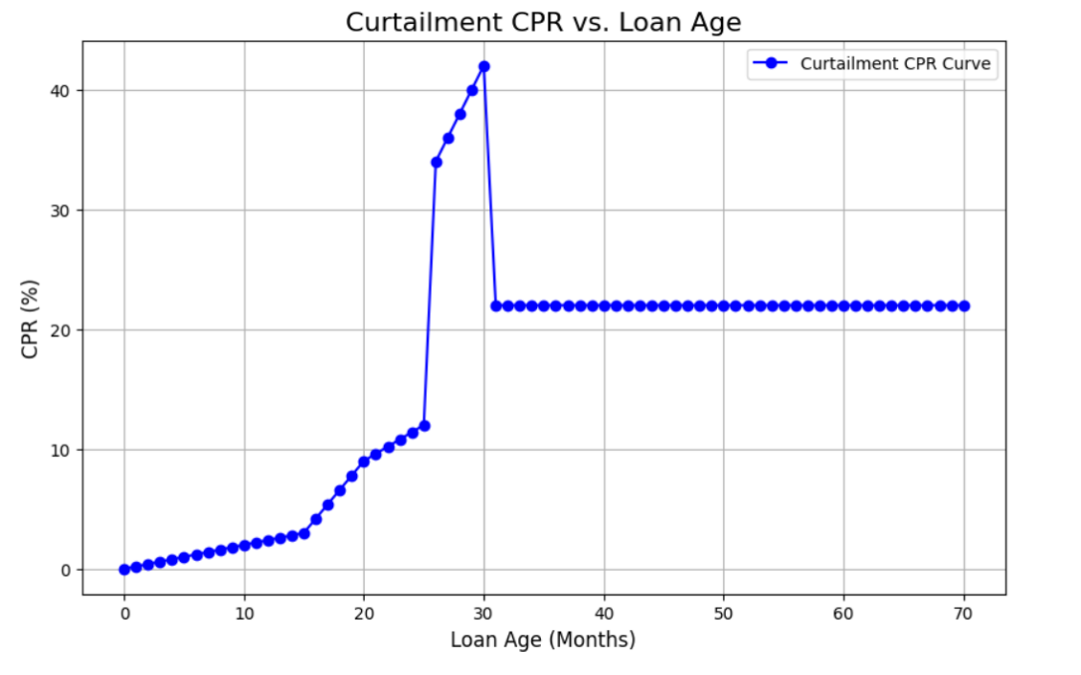
- CPR and Loan Age Relationship:
  - The graph shows how the Curtailment Prepayment Rate (CPR) changes as the loan age increases.
  - Initial Growth: As the loan age reaches around 20-25 months, the CPR starts to increase gradually, indicating more borrowers are making extra principal payments.
  - Sharp Spike: A significant spike in CPR occurs around the 30-month mark, where it reaches over 40%. This suggests that a large portion of borrowers decide to curtail at this point, possibly due to specific financial incentives or milestones.
  - Plateau: After the sharp increase, the CPR stabilizes at a high rate and remains constant beyond the 30-month mark, implying that borrowers continue to make partial prepayments at a consistent rate.

Key Points from the Text:
- Curtailments refer to extra payments made toward the principal beyond the regular monthly mortgage payment. By doing so, borrowers effectively shorten the remaining term of their mortgage.
- Fixed Payment Structure: For a level payment mortgage, sending in larger monthly payments reduces the remaining principal and, therefore, the term of the loan.
- Function of Loan Age: The curtailment pattern shown in the graph is tied to the loan's age, represented by the function in the context.
The graph highlights a pattern where the Curtailment Prepayment Rate sharply increases at a particular loan age (~30 months) and then stabilizes. This behavior reflects borrower tendencies to make extra payments to shorten the loan term, with significant prepayment activity concentrated in the early life of the mortgage.

Part 2: Credit Modeling
This section of the final project focuses on default modeling, where loan data from 2015 and 2019 is preprocessed to predict the probability of loan default.
1. Data Preprocessing:
- Key Feature Extraction: Important features for predicting default probability are extracted, including FICO credit score, Original UPB (loan amount), Occupancy Status, Loan Purpose, Debt-To-Income ratio (DTI), and Property State.
- Current Loan Delinquency Status: The loan delinquency status data is processed to determine whether a loan is in default.

2. Feature Extraction:
- The data is grouped by loan identifiers, using the most recent records for each loan.
- Defining Default Status: Loans are classified as default if the delinquency status shows three or more months of missed payments (status = 1), otherwise, they are classified as non-default (status = 0).
- This process is applied to both the 2015 and 2019 datasets to obtain the features and target variables needed for model training.

3. Model Training:
- Before training, the data is split into an 80% training set and a 20% test set to ensure the model's performance is evaluated on unseen data.
- Feature Transformation: The data is split into numerical features (such as FICO score, loan amount, and DTI) and categorical features (such as Occupancy Status, Loan Purpose, and Property State). Numerical features are standardized, and categorical features are one-hot encoded.

4. Model Evaluation:
- Logistic Regression: As a linear model, logistic regression is suited for linear relationships. However, it struggled to capture the nonlinear patterns in this dataset, resulting in a lower accuracy of around 60%.
- Decision Tree Model: The decision tree performed the best, with an accuracy of 65%, as it could capture nonlinear patterns in the data by adaptively splitting features at various thresholds.
- Random Forest Model: Despite being an ensemble method designed to improve performance, the random forest model also achieved around 60% accuracy, similar to logistic regression. This may be due to the lack of hyperparameter tuning.

5. Future Improvement Directions:
- Hyperparameter Tuning:
  - For Random Forest: Tuning hyperparameters such as the number of trees, maximum depth, and the number of features considered at each split could improve the model's performance.
  - For Decision Tree: Adjusting the depth of the tree or the minimum number of samples required to split a node could prevent overfitting or underfitting and enhance the model's ability to generalize.
- Ensemble Learning: Combining predictions from multiple models (e.g., using a voting classifier with logistic regression, random forest, and decision tree) could provide a more robust and accurate prediction.
Overall, the project successfully builds models to predict loan defaults and offers suggestions for future improvements to enhance the accuracy and robustness of the predictions.

